Originator:
Name | Job Title | Signature | Date
Jan Ayres | Project Implementation Manager
Approvals:
Name | Job Title | Signature | Date
Nancy Rizzo | Founder and CEO
Michael Stowell | Chief Financial Officer
Andrew Mason | Chief Technology Officer
Scott Pletzer | Quality and Project Implementation Director
Don Pegg | Senior Electrical Engineer
Andrea Miller | Quality Assurance Manager

Revision History
Revision | Revision Date | Reason for Revision/Change Request | Revised By
000 |  | Initial Release

PURPOSE

The purpose is to define the Design & Development Plan (DDP) for replacing the camera in the EPIC ClearView device. A new camera must be sourced and engineered into the device because the camera that is currently used is no longer manufactured. This DDP will provide a comprehensive view of the project to assist the design team in successful completion of each phase and activity.

This will ensure that all necessary activities are addressed including the method in which they will be conducted and all responsible parties involved therein.

SCOPE

The objective of this DDP is to outline the activities to be performed in order to identify, develop, and implement a replacement camera for the Philips SPC 900NC camera currently used in the ClearView device. Included in this document are the roles and responsibilities of individuals that are required to perform these activities.

Aspects of the design process included within this DDP are planning, design, verification, validation, and design transfer. Included in the plan are all individuals, resources, and facilities involved.

REFERENCE DOCUMENTS

Regulatory Documentation:
- FDA 21 CFR 820, Quality System Regulations (QSRs)
- ISO 13485:2003 Medical Devices – Quality Management Systems – Requirements for Regulatory Purposes

GEOST ClearView Replacement Camera Report

Project requirements

Camera and lens assembly capable of capturing an energized image.

Camera capable of image capture at a minimum of 15 pictures/10 second exposure.

Camera must be able to be controlled through the software for all settings pertaining to image quality.

Camera parameters to match the existing Philips SPC 900NC camera as close as possible. Current specifications for the SPC 900NC were identified in the GEOST ClearView Replacement Camera Report and are listed in Attachment 1. The GEOST report is contained in Attachment 2

Implement replacement camera based on recommendations in the GEOST ClearView Replacement Camera Report.

RESPONSIBILITIES

Quality and Project Management Director – oversight of camera selection, subsequent design controls, and implementation.

Chief Financial Officer – oversight of project financial considerations.

Quality Assurance Manager – management of quality system requirements.

Chief Technology Officer – development of CV software interface.

Engineering Department – development of design specifications, implementation into manufacturing, and verification of performance standards with ClearView system. Note: Currently Engineering efforts are outsourced to Phoenix Analysis and Design Technologies, Inc. (PADT)

organization, interfaces, responsibilites, and approval authority

All pertinent steps and documents, such as design control documents, design review, verification, and validation, must be approved by the following departments:
- Executive Management
- Operations
- Information Technology
- Quality Assurance
- Engineering

All Engineering Studies must have the signature of the following departments:
- Quality Assurance
- Engineering
- Information Technology (as applicable)

Major Tasks (Milestones) & Schedule

Camera replacement options are sourced for the Philips SPC 900NC based on current camera parameters and financial considerations. (December, 2011)

Review and approval of DDP by Executive Management.

Acceptable replacement camera identified and rationale for selection developed.

Project team updates plan.

Design review of formalized plan.

Design inputs and outputs are documented and approved.

Design developed resulting in design outputs documentation.

Periodic design reviews as appropriate.

Design verification and validation.

Final design review and approval.

Design release for manufacturing.

Design verification & Validation Approach

Design verification and validation will include at a minimum an assessment of calibration images to ensure they meet existing standards, and an assessment of human subject images to existing standards. Additional testing may be necessary and will be implemented based on project plan.

risk analysis

Plan will incorporate the change into the current risk analysis to evaluate any impact.

Project constraints

The project has a business need to identify and implement a camera replacement prior to manufacturing additional devices. Any additional constraints will be noted in a further revision of this plan.

Design history file (DHF)

The outputs of this effort will be added to the current DHF.
Attachment 1
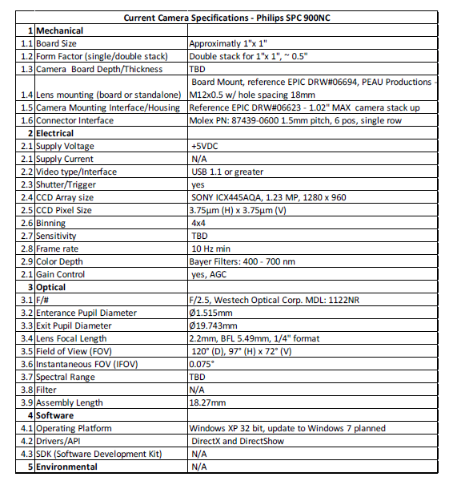
Attachment 2
GEOST ClearView Replacement Camera Report

